**Exception handling:**

How do you exception handling in your web application?

1. Layered architecture. We catch exceptions in the controller layer.
2. Exceptions from ur repository layer, propagated to controller layer generally using ur custom exceptions
3. In controller layer, return proper response with set error message
4. If exception is particular to a method, try catch
5. If exception is being thrown by more than 1 method in a controller,

@ExceptionHandler(DatabaseExcepion.**class**)

**public** **void** handle(DatabaseExcepion e, HttpServletRequest request, HttpServletResponse resp) **throws** ServletException, IOException {

request.getRequestDispatcher("error.jsp").forward(request, resp);

}

If this is placed inside the controller, it will only handle DatabaseException only for this controller

1. If this exception is being thrown by more than 1 controller, and we want to handle it

@ControllerAdvice

**public** **class** TheExceptionHandler {

@ExceptionHandler(DatabaseExcepion.**class**)

**public** **void** handle(DatabaseExcepion e, HttpServletRequest request, HttpServletResponse resp) **throws** ServletException, IOException {

request.getRequestDispatcher("error.jsp").forward(request, resp);

}

}

This is a controllerAdvice, meaning a service for all the controllers.

2)

**Databinding**

@ModelAttribute, BindingResult, @Valid

Controller can return ModelAndView// String (viewname)

@EnableWebMvc, @RequestParam , @InitBinder

Method annotated with @ModelAttribute is called before any bean is mapped.

@ModelAttribute

**public** **void** init(Model model) {

model.addAttribute("header", LocalDate.*now*());

model.addAttribute("footer", "Bansal Coaching institute");

}

So on any view I can use this header and footer

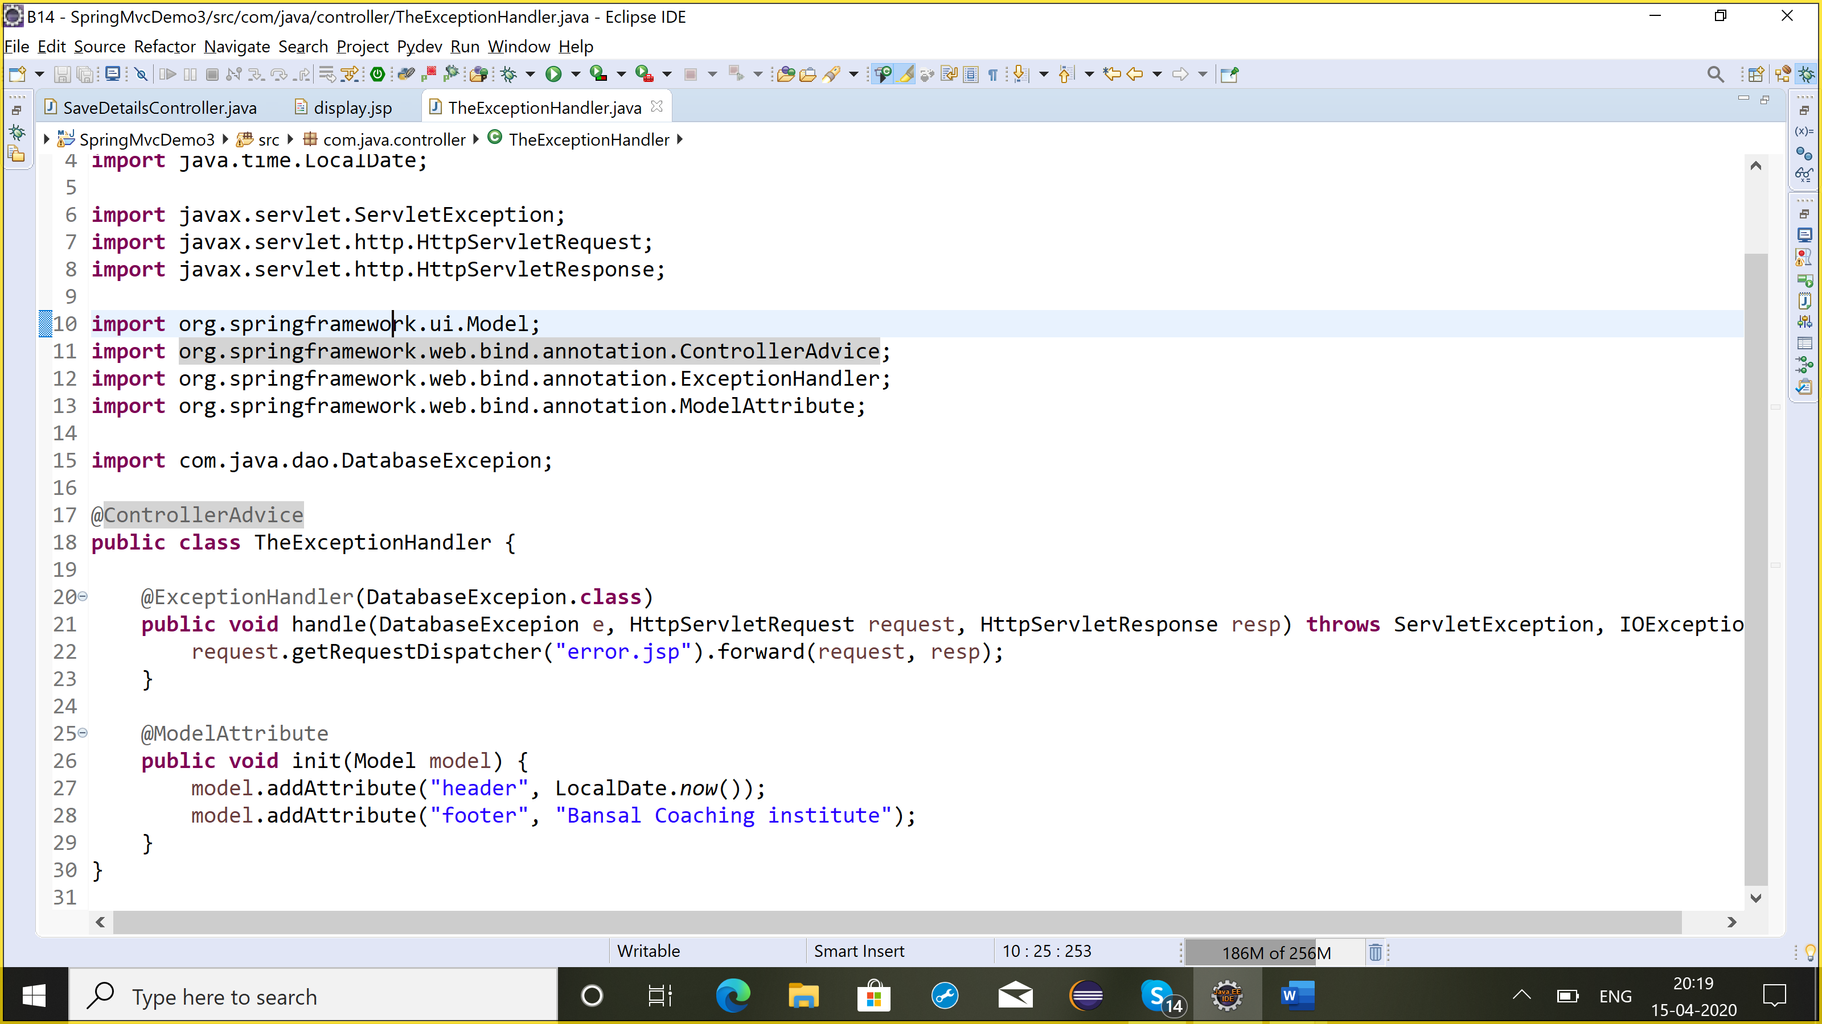

**Internationalization**

Spring+ Hibernate**: spring orm**

LocalSessionFactoryBean

HibernateTemplate

**Spring-jdbc: JDBCTemplate**

**JDBCTemplate**

Spring+ jdbc

//update: DML

//query: dql

//execute: ddl

Automatic transaction commit, each statement of template is auto-commit (DML)

It automatically manages connection object

Lot of query methods, queryForObject, queryForList, queryForMap